I'm sorry, my English proficiency is not very high. Please provide a letter of guarantee for any mistakes made

I'm very sorry for the hasty instructions. My software has a lot of functions to do, so please don't worry about being detected by GL. It only imitates mouse and keyboard operations by detecting changes in the game screen. Many operations are automated, and I may not be able to finish them all at once. If you have any questions, please contact me

.

**Please make sure to set it this way within the game**

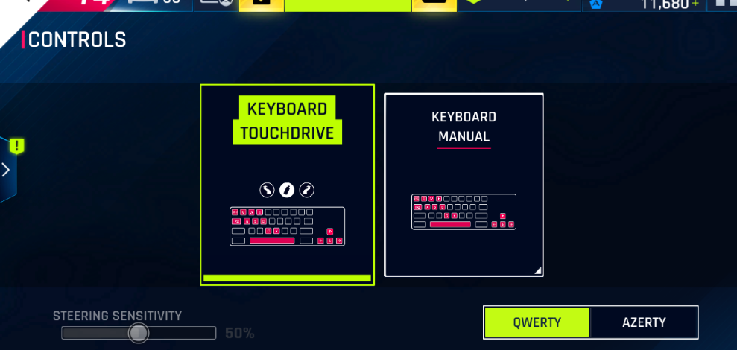

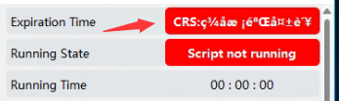

If the above situation occurs during runtime, please set it according to the following diagram

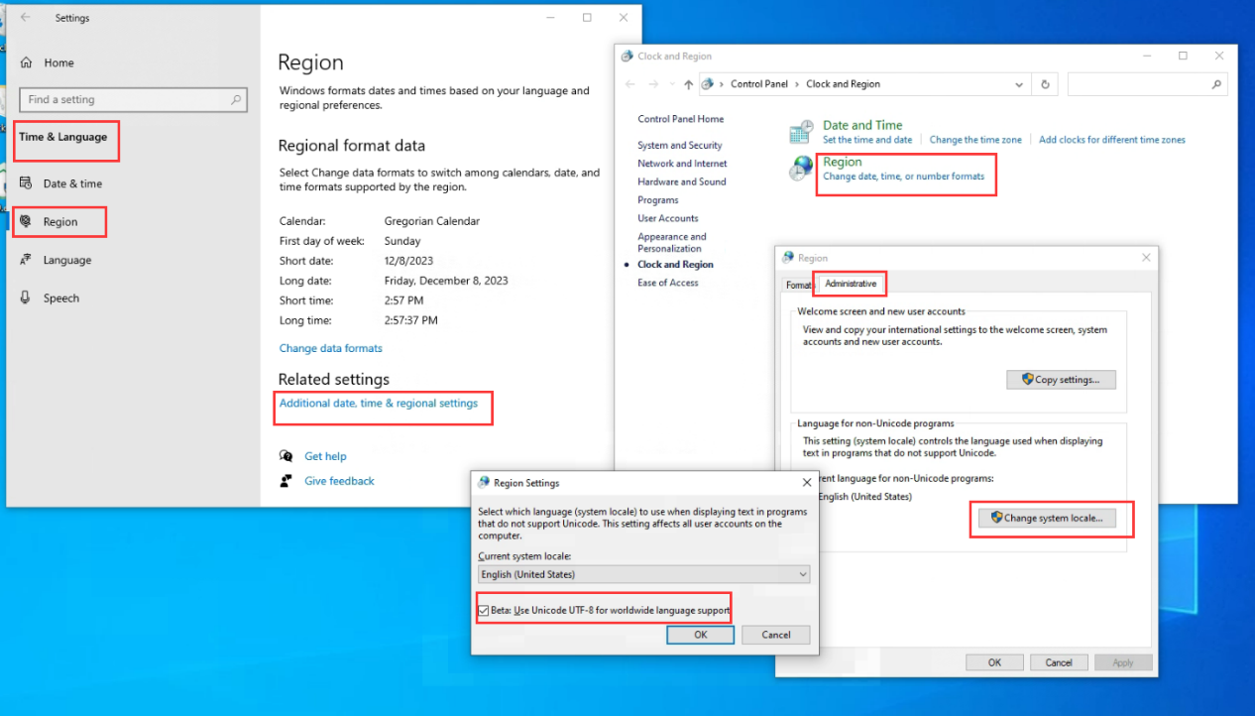

Let's focus directly on how to set up the project

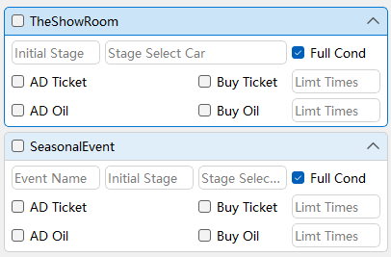

**Initial stage**: Simply fill in the numbers corresponding to the initial stage, and the script will automatically identify the unfinished conditions for operation until the ticket is used up and enters the next project. If the stage is completed, it will automatically enter the next stage to continue

**Event Name:** Please fill in a part of the event name, such as: 300

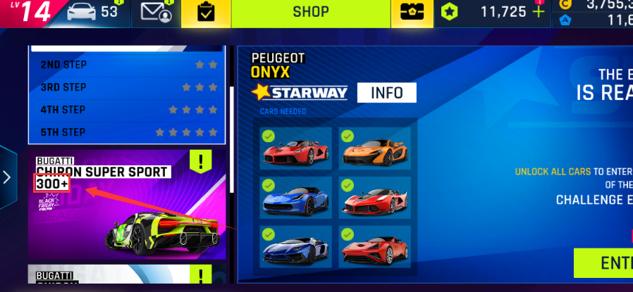

**Select car:** The number of vehicles that can be set from the initial stage onwards. such as:

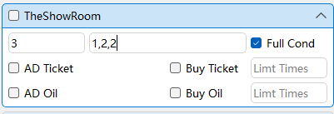

Means: stage3:first car stage4:2th car stage5:2th car

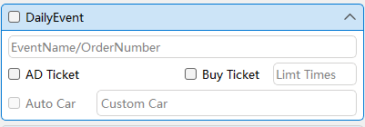

**Eventname:** You can fill in a part of the event name, or you can also fill in the number of events

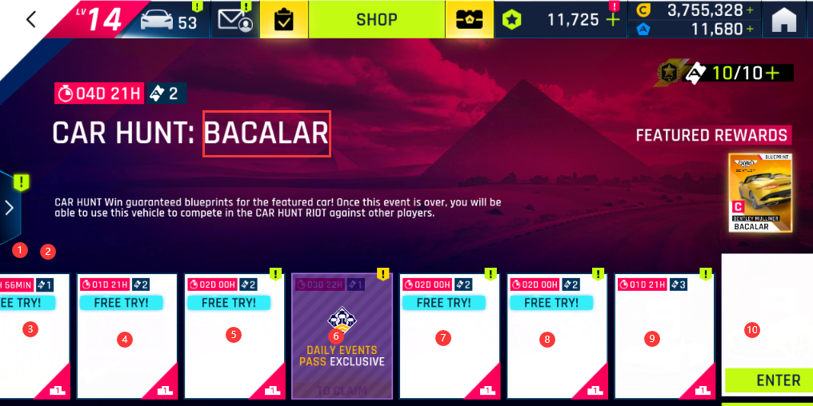

**Let's focus on car selection:**

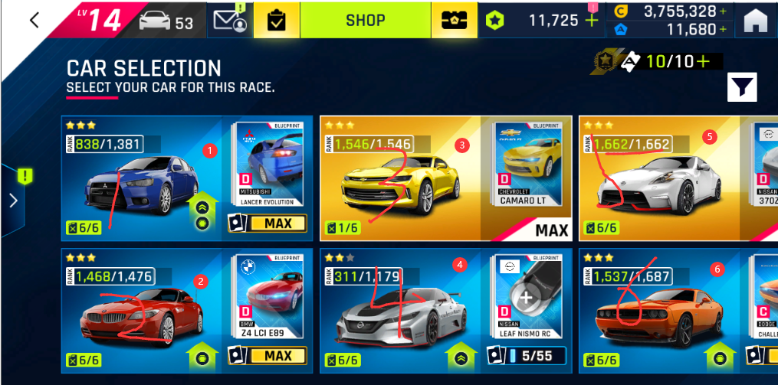

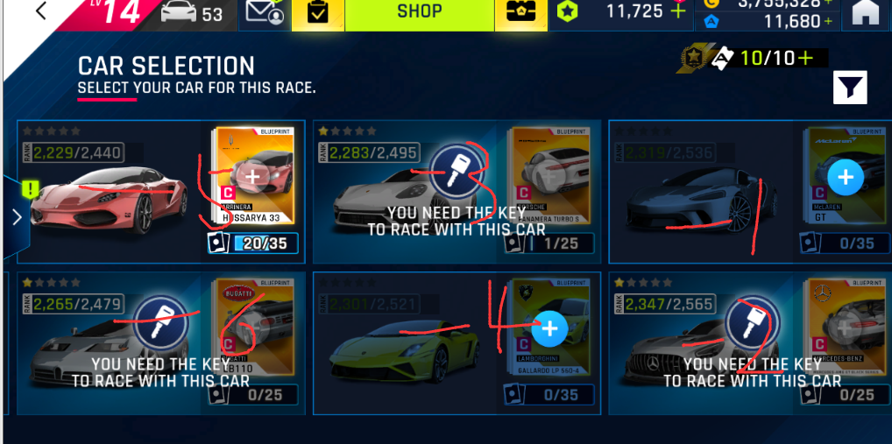

For example, if you want to choose Nissan, you can fill in 5, but you cannot only use one car. You can use commas to separate them, and when you run out of gas, the next car will be used automatically

If you have a lot of cars and don't want to count backwards one by one, you can also use negative numbers to represent counting backwards, all of which can be mixed together

I will also add an automatic car selection function in the future, which will automatically judge based on the performance of your car and whether it meets the conditions. This way, the setting is simpler, and you only need to tell the software what you want to run

All car selection rules are the same, and in multiplayer1, each stage starts from the first car in that stage

If you need to select cars consecutively and don't want to fill them out one by one, you can use colons to separate them. n: m means counting from n to m, both positive and negative numbers are acceptable. For example, in this multiplayer2, you can set it as -1:-17 or 17:1

